**Project Design Phase**

**Problem – Solution Fit Template**

|  |  |
| --- | --- |
| Date | 24-06-2025 |
| Team ID | LTVIP2025TMID49405 |
| Project Name | Measuring the Pulse of Prosperity: An Index of Economic Freedom Analysis |
| Maximum Marks | 2 Marks |

**Problem – Solution Fit Overview**

**Problem:**

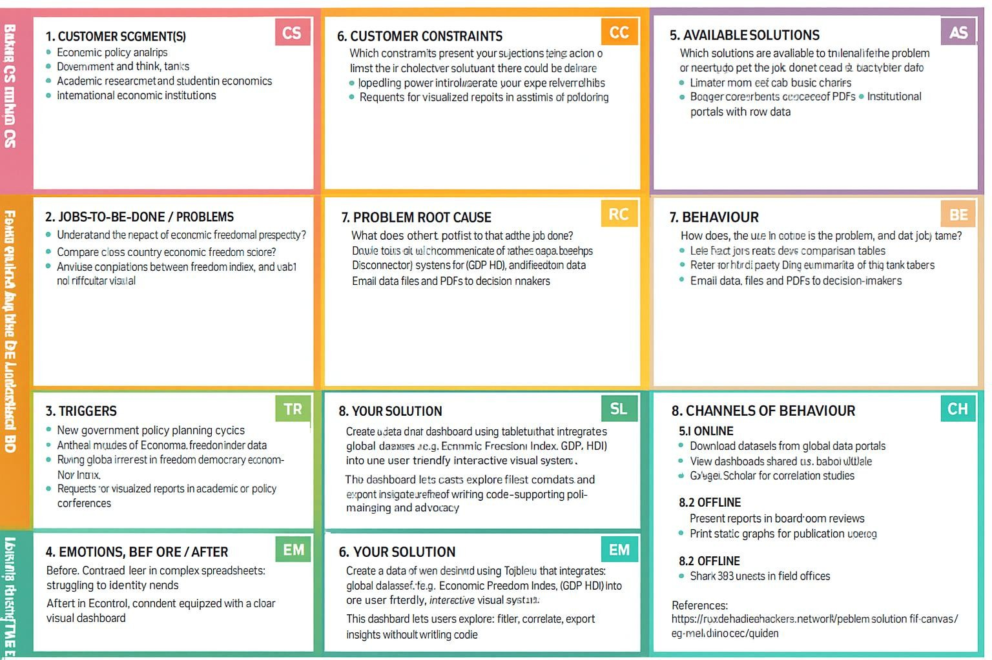Policymakers, researchers, and economists struggle to compare economic freedom across countries in a meaningful, interactive, and visual way. Static reports and raw data formats make it difficult to identify patterns or correlations between freedom indices and prosperity indicators such as GDP per capita or HDI. As a result, strategic policy insights are underutilized.

**Solution:**

This project uses Tableau dashboards powered by cleaned and analyzed economic data (from sources like the Heritage Foundation and World Bank) to provide interactive visualizations that explore how economic freedom impacts national prosperity. Users can filter, compare, and download insights for deeper policy or academic decision-making.

**Template:**

References:

1. <https://www.ideahackers.network/problem-solution-fit-canvas/>
2. <https://medium.com/@epicantus/problem-solution-fit-canvas-aa3dd59cb4fe>